MotoGPManager Report Results:

It can be seen in the reporting that although extensive automated testing of the “back end” API has been completed, the manual testing of the front end can be improved with solenium tests.

During sprint 2, I would implement further testing automating the manual process that is being performed for each alteration.

Current list of manual tests:

index.html

- Get All functionality for all pages fully functional.
- Get Single button functionality for all pages fully functional.
- Get Single input functionality for all pages fully functional.
- Clear Table button functionality fully operational.
- Go to modification page button fully operational.

Modify.html

- Create, Update and Delete Rider
- Create, Update and Delete Teams
- Create, Update and Delete RaceLogEntries

Automated Reports

Surefire report summary below;
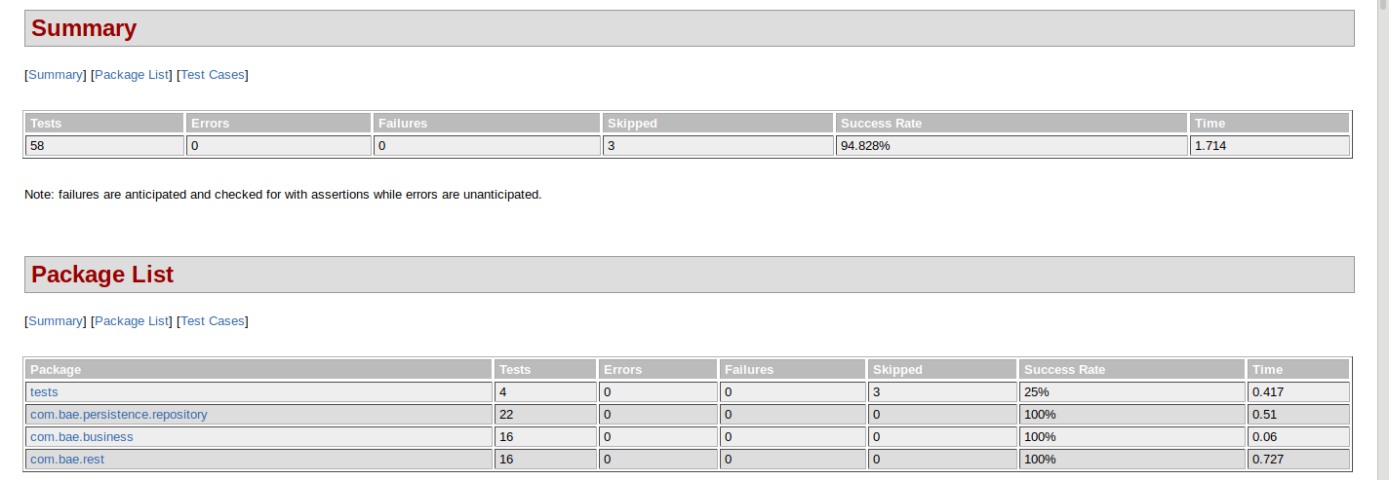
From the automated API testing, you can see that each layer of the API has been tested, with all key areas returning 100% success rate.

There are additional tests that are returning as skipped however they are no longer relevant and will be removed during Sprint 2. The tests in question were for the Map/DB functionality, which was not implemented fully during sprint 1.
Jacoco report summary below;
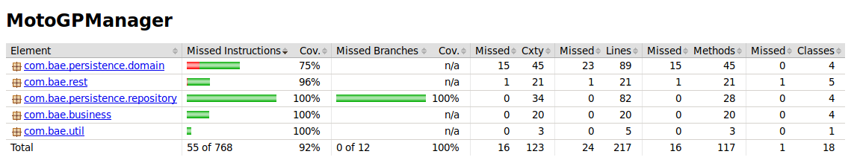
As can be seen above, the coverage requirement of 80% has been met with automated testing.

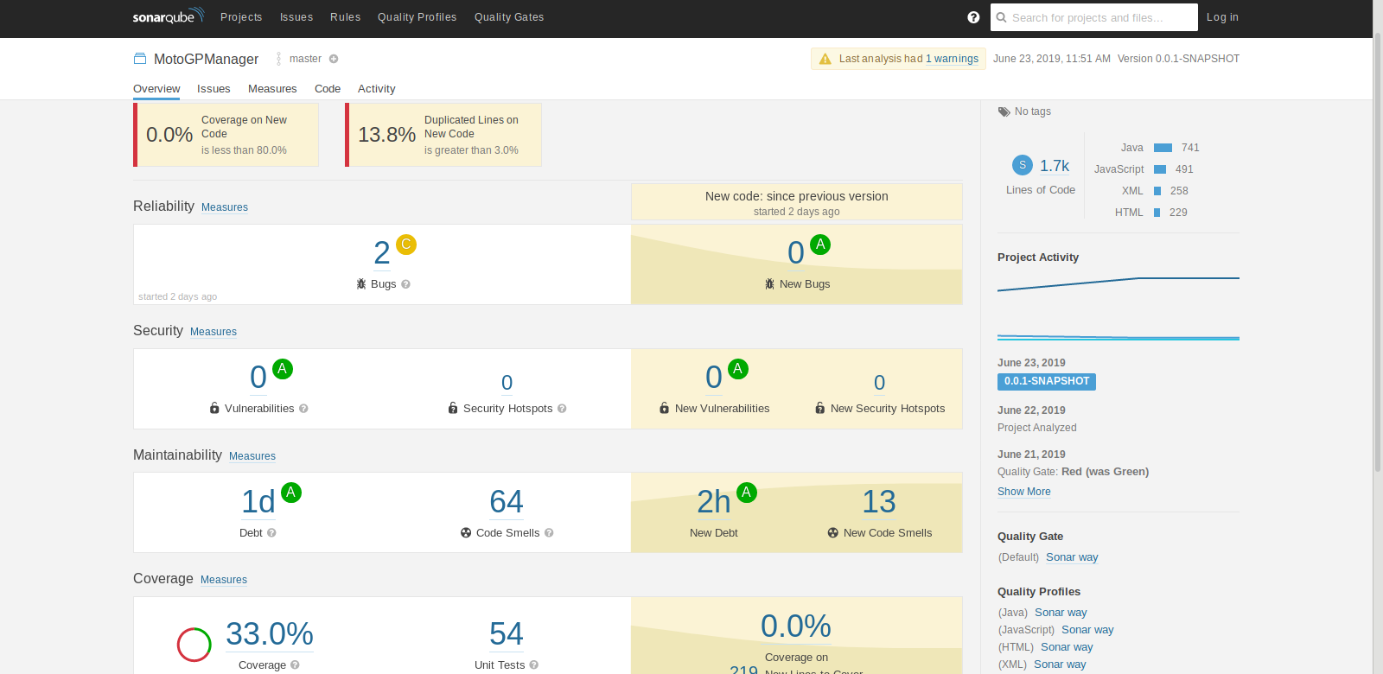
Sonarqube

The sonarqube reporting shown above and accessible here, shows a few areas of improvement to be made during sprint 2.

Areas of focus would be on the 2 bugs within the HTML code for “Insert a <!DOCTYPE> declaration to before this <html> tag.” and the 64 code smells for items such as removal of unused code and comments.

Note should be made however regarding the coverage reporting, due to the fact this takes into account JavaScript and HTML files, the coverage is much lower than on Jacoco. However for the purpose of this project, we are focusing solely on the Java testing for the coverage requirement of 80%.

